Easter in France

Easter in France is called Pâques and to wish someone a Happy Easter you say Joyeuses Pâques. Good Friday is called Vendredi Saint.

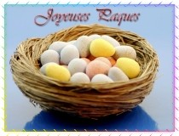

The main items in the celebration of Easter in France are chocolate eggs (les oeufs en chocolat) and chocolate bells (les cloches). Easter bonnets and Easter bunnies are not really very French, although Easter chicks are also used.

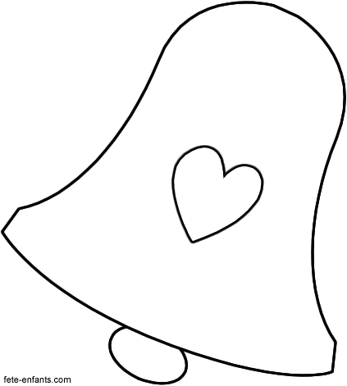
Les cloches volantes

Chocolate bells are a feature of a French Easter because of the following story: On Good Friday all the church bells are silenced and the children are told that the bells have flown, as if by magic, to Rome to be blessed by the Pope, taking with them all the misery and grief over Jesus’ death. Although the bells are still visible, it is understood that they will not be heard ringing again until Easter Day. These flying bells return on Easter Sunday morning, when they are upside down and full of chocolate Easter eggs. When the bells start to ring out, the swinging action tips the eggs in to people’s gardens and treasure hunts are held to retrieve the chocolate treats.
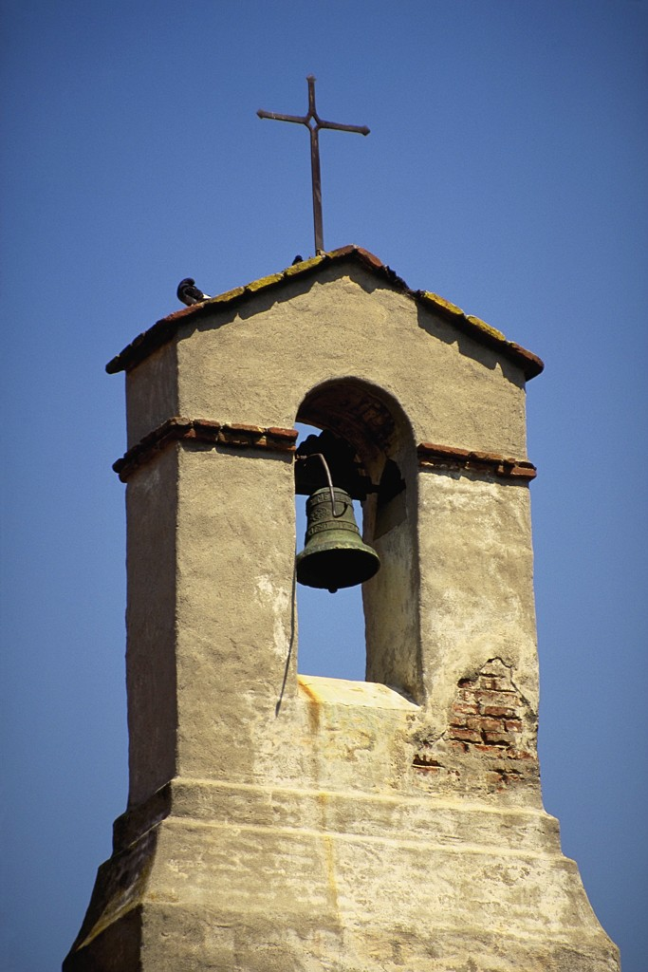

Easter Games
- Children might play a game of tossing raw eggs in the air. The first child to drop and break his egg is the loser, and in some versions, must pay a penalty (e.g. give up a piece of his Easter chocolate)
- Raw eggs are rolled down a slope and any egg which survives unbroken is the winner and it symbolises the stone rolling away from Jesus’ tomb.

French Confiseries and Chocolatiers

Easter is the perfect time of year for master chocolatiers to display and celebrate their artistic flare. Great attention to detail and years of practice result in wonderful displays of chocolate eggs, bells and fish.

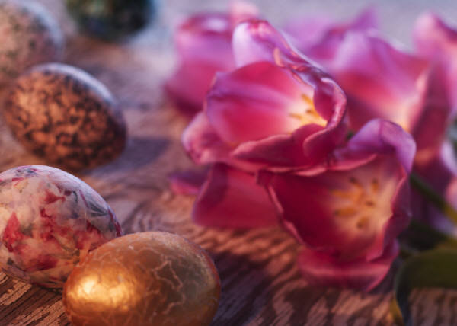

Poissons d’avril
As well as chocolate eggs and bells, the French also enjoy chocolate fish (poisson d’avril) through the Easter period. These start appearing in shops on April 1st, when children use paper versions to play an April Fools type trick. The 'trick' is to stick a paper fish onto the back of as many adults as possible, then run away shouting, "Poisson d'Avril!" (April fish!). The tradition is several centuries old.


La fête des mères

This is similar to Mothering Sunday, but doesn’t happen as in Britain on a Sunday leading up to Easter, but rather usually on the last Sunday in May. In 2011 in France La fête des mères will be on the 29th May. Cards are available for the special day and some wonderful cakes can be bought in the pâtisseries to mark the occasion.



Le 1er mai

The First of May is a special day in France when it is traditional to give friends small bunches of the flower of the month, lily of the valley (muguet), which signifies a return to happiness. This acts like a symbol of the ending of the long unproductive period of winter and the arrival of spring when the plants and flowers will come into bud and is supposed to bring Good Luck.

